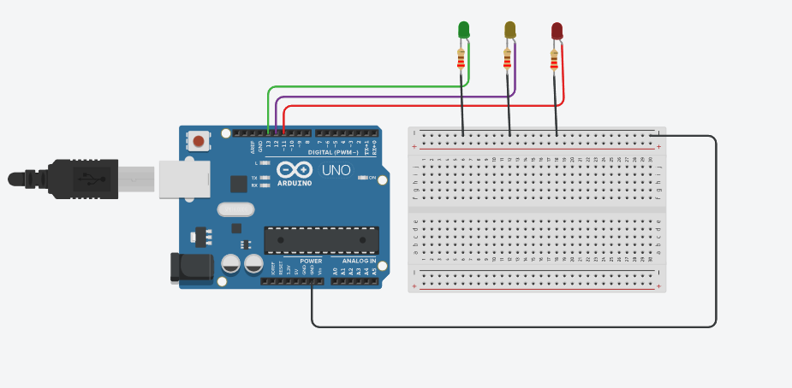

int counter = 0;

void setup() {

pinMode(13, OUTPUT);//for green LED

pinMode(12, OUTPUT);//for yellow LED

pinMode(11, OUTPUT);//for red LED

Serial.begin(9600);

}

void loop() { counter += 10;

Serial.println(counter);

if (counter < 100) { digitalWrite(13, HIGH); digitalWrite(12, LOW); digitalWrite(11, LOW);

}

else if (counter >= 101 && counter <= 200) { digitalWrite(13, LOW); digitalWrite(12, HIGH); digitalWrite(11, LOW);

}

else if (counter > 200) { digitalWrite(13, LOW); digitalWrite(12, LOW); digitalWrite(11, HIGH);

}

delay(1000);

if (counter > 300) { counter = 0;

}

}